Ananthu S

Front-End Developer

**** Kottayam, Kerala, India **** +91 7012022083 **** ananthusoff@gmail.com

Front-end developer with 6+ years of experience in building, deploying and maintaining user-focused and responsive web applications in financial and retail domains

Profiles

ananthu-

[s](https://www.linkedin.com/in/ananthu-s-3b35ba7b)

ananthus-de

[v](https://github.com/ananthus-dev)

Summary

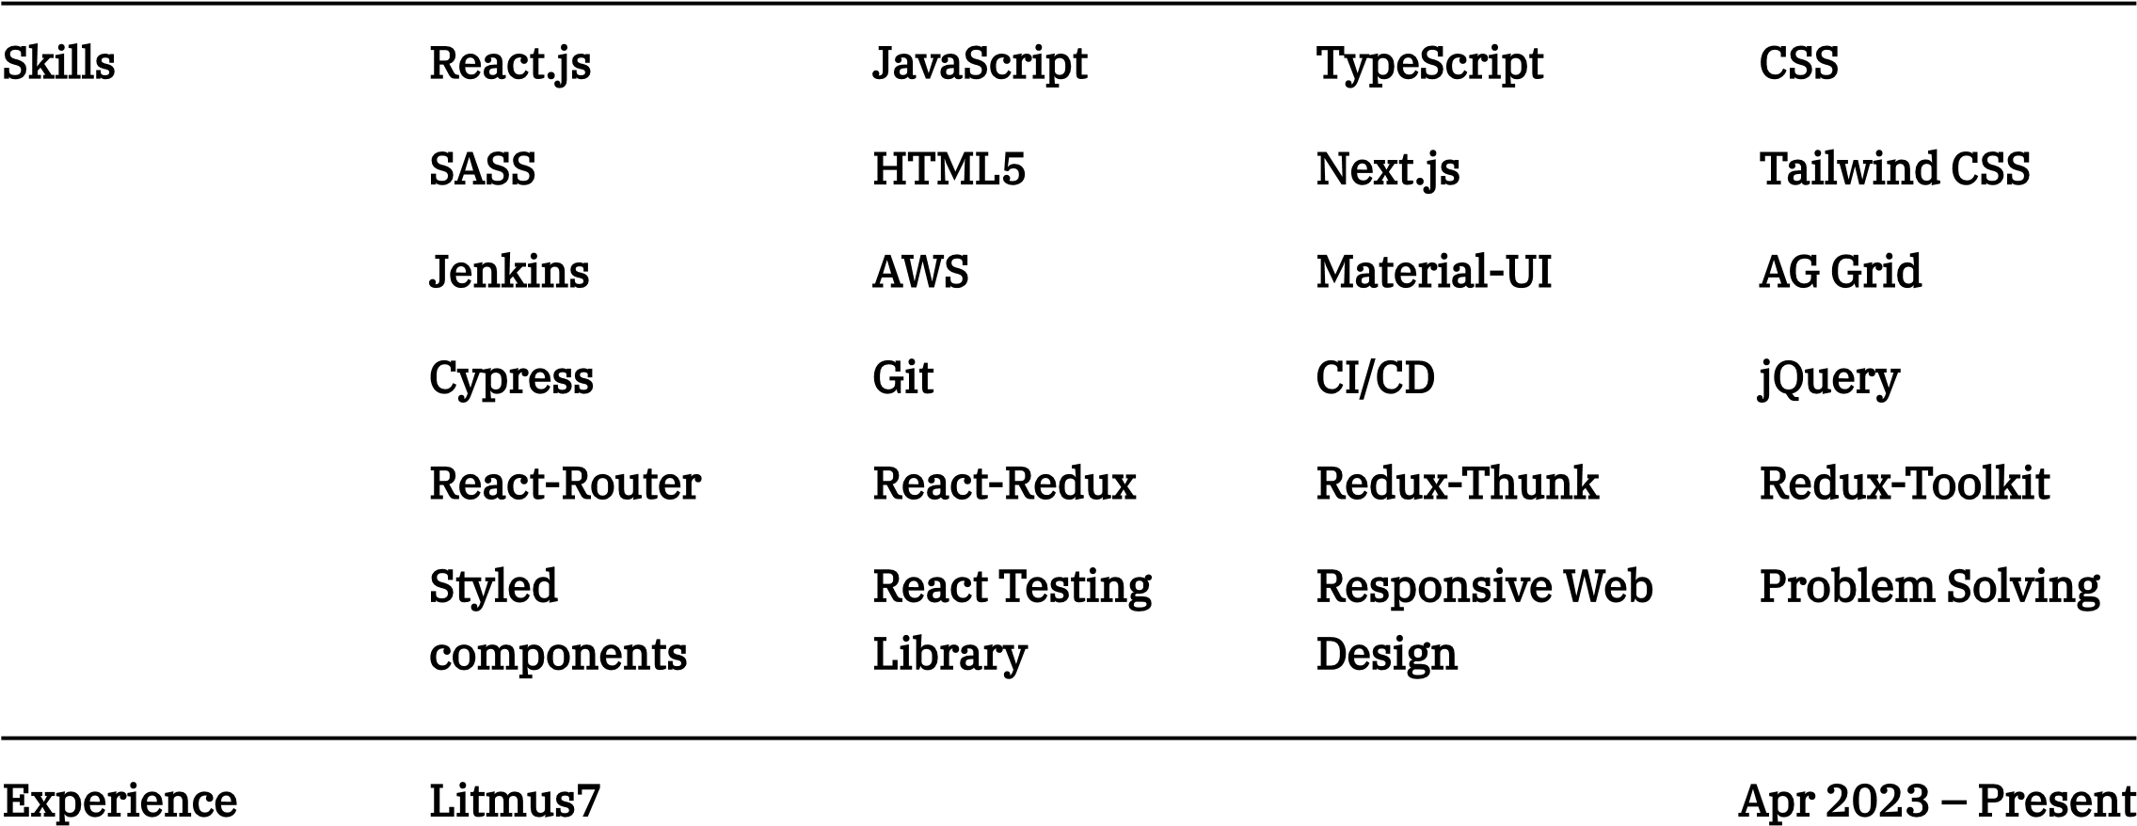

|  |  |
| --- | --- |
| Technology Specialist | Kochi, Kerala, India |
| Litmus7  Senior Engineer | Aug 2021 ~~–~~ Mar 2023 Kochi, Kerala, India |
| Envestnet, Inc  Senior Engineer - Product Development | Oct 2019 ~~–~~ Aug 2021  Trivandrum, Kerala, India |
| Envestnet, Inc  Engineer - Product Development | Jul 2017 ~~–~~ Sep 2019  Trivandrum, Kerala, India |

# Certifications & AWS Certified Solutions Architect ~~-~~ Associate (SAA- C02)

Jun 2022 ~~-~~ Jun 2025

Achievements Amazon Web Services (AWS)

**** <https://www.credly.com/badges/addc9581-dcac-45d1-95cc-cc1ebc4361ef>Score~~:~~ 823/1000

# HackerRank ~~-~~ 6 Star Gold Badge (Problem Solving ~~-~~ JavaScript)

HackerRank

**** <https://www.hackerrank.com/profile/ananthus123>

2013-2017

Points:

2217

Education

Rajiv Gandhi Institute of Technology

,

Kottayam

,

Kerala

Electronics and Communications

B.Tech 8.15 CGPA

# St.Dominic's Higher Secondary School, Kottayam, Kerala 2011 ~~-~~ 2013

97.5% Higher Secondary

1999 ~~-~~ 2011

A.K.J.M High School, Kottayam, Kerala

High School

# Detailed Work Litmus7 Aug 2021 ~~-~~ Present Experience The Container Store

Revamped the existing checkout page using React.js

Integrated payment methods like PayPal and AfterPay

Conversion of existing legacy (JSP) pages using Next.js

Implemented various Kibo and Adobe analytics requirements

Integrated Prismic (CMS) to show marketing content

Performance analysis and optimization using Lighthouse

Extracted the header and footer section into a separate npm library which can be reused across pages

Developed the BOPIS PWA application which enabled the store associates to process the buy online, pick-up in store orders in a timely and efficient manner

Skills: React.js, python, Next.js, TypeScript, JSP, SASS, AWS, Styled components, Material-UI,

Formik, jQuery, Redux-Toolkit, React-Router

# Lowe's

Led and implemented unit testing of UI components using React Testing Library

Increased the code coverage from 75% to 90%

Led and implemented Cypress Automation for the Pro Loyalty pages

Integrated the automation with CI/CD pipeline to enable automatic regression testing when a new build is deployed

Generated automation report using Allure Report

Skills: React Testing Library, Jest, Cypress, Jenkins, Allure, BitBucket

# BJ's Wholesale Club

Led a team of 5 people to build a POC based on Bloomreach headless CMS

Skills: React.js, Bloomreach, Tailwind CSS

# Detailed Work Envestnet, Inc Jul 2017 ~~-~~ Aug 2021 Experience Wealth Management Platform

Development of new pages and conversion of existing pages using React.js

Created customizable and reusable UI components using React-Material UI library

Developed a customizable dashboard which enable users to add, remove, relocate and resize the various widgets

Developed pages which contain tables that support in-cell editing and thousands of rows without affecting overall page performance

Developed a configuration driven account search page which supports searching using more than 100 filter criteria Ability to dynamically add/remove filter criteria

Skills: React.js, CSS, python, AWS, Material-UI,AG Grid, Storybook, TypeScript

# API Documentation Portal

Developed an internal API documentation portal which gives the details of various APIs

Created an in-memory database using LokiJS by parsing the Swagger JSON files, which serves as the data source for the UI Developed the UI of the application using React.js

Skills: React.js, LokiJS, CSS, React-Redux, Redux-Thunk

# Web Scraping Project

Developed a web scraping application using Python and BeautifulSoup, for collecting and parsing financial advisors data

Improved the throughput of the application using multi-threading

Created several SQL tables and procedures for storing the collected data

Skills: Python, AWS ,BeautifulSoup, SQL

# Personal Projects COVID Vaccine Slot Notifier Jun 2021

**** <https://github.com/ananthus-dev/cowin-telegram-vaccine-notify>

Node.js based backend service to notify the users about vaccine slot availability through Telegram

Used Co-WIN Public API to get information on vaccine slots

Used Node.js and MongoDB

Users can register/deregister pin codes by sending message to the Telegram Bot

Used Node.js Telegram Bot API module to interact with the official Telegram

Bot API and send messages to users

Deployed the application in AWS Elastic Beanstalk

Skills: Node.js, Express.js, MongoDB, AWS